|  |
| --- |
| [**Delivery guidelines - Receipt of goods**](http://www.br-automation.com/smc/521938a7da364584f7a30466fe87782278a6acc6.pdf)  **V04** |
|  |

1. Table of contents

1 Purpose 2

2 Description of functions 2

1 Brief summary 4

2 Applicability 4

3 Glossary 4

3.1 Delivery 4

3.2 Delivery item 4

3.3 Packaging unit 4

3.4 Delivery unit 4

3.4.1 Packages 4

3.4.2 Load carriers 4

3.4.3 Pallet crates 5

3.4.4 Disposable pallets 5

4 Receiving times 5

5 Delivery note 5

6 Labels 5

6.1 Package label 6

6.2 Material ID label 6

7 Abbreviations 6

8 Packaging load carriers 7

8.1 Single-type load carriers 7

8.1.1 Single-type load carrier with packaging units 7

8.1.2 Single-type load carrier with outer packaging (packages) 7

8.1.3 Weight distribution 8

8.1.4 Positioning the packaging units on the load carrier 8

8.2 Load carrier with a mix of products 8

8.2.1 Load carrier with a mix of products in packaging units 8

8.2.2 Load carrier with a mix of products in single-type packages 9

8.2.3 Load carrier with non-single-type packages 9

8.2.4 Positioning packaging units or packages 10

9 Packaging package deliveries 10

9.1 Single-type packages 10

9.1.1 Mixed packages 11

10 Inspection documents 11

11 Maximum delivery weight 11

12 Using packaging materials 11

13 Labels on circuit packaging 11

14 Exchanging palettes 11

15 Protection against damage 11

16 Consequences resulting from failure to follow delivery guidelines 12

# Brief summary

* Delivery times:

Plant Eggelsberg: From 6:00 AM to 6:00 PM

Plant Gilgenberg: From 6:00 AM to 3:00 PM (Mon – Thu)

From 6:00 AM to 11:30 AM (Fri)

* Load carriers: Height: max. 1.9 m, weight: max. 900 kg, 4 cm margin along the

edges, ensure even load distribution!

* Packages: Weight: max. 20 kg
* Unique ID of each packaging unit with bar code
* Delivery note for each delivery item or package

# Applicability

This guideline describes the conditions applicable at B&R for packaging and delivery methods and is part of all contractual agreements unless separate agreements are made. Any changes or additions to these guidelines are only valid in written form.

# Glossary

## Delivery

A delivery is defined as all of the goods being delivered at a specific delivery time. A delivery can consist of multiple products (delivery items), and delivery items from multiple orders can be combined into one delivery.

## Delivery item

If a delivery contains several different products, then each of the products included in the delivery is referred to as a delivery item.

## Packaging unit

A packaging unit is the smallest package in which a product is packaged. A packaging unit must always contain the same type of products.

## Delivery unit

A delivery unit is a combination of one or more packaging units that are ready for delivery. Delivery units are delivered either as packages or on a load carrier (EUR-pallet). Delivery units can be limited to one type of product or contain several delivery items.

### Packages

A package refers to the packaging of one or more packaging units ready for delivery.

### Load carriers

A load carrier is a EUR-pallet on which multiple packaging units or packages are combined and readied for delivery.

According to the UIC 435-2 standard from EPAL (European Pallets Association), EUR-pallets must have the dimensions 800 x 1200 mm (www.epal-pallets.org).

### Pallet crates

The use of pallet crates is not permitted.

### Disposable pallets

The use of disposable pallets is not permitted.

# Receiving times

Plant Eggelsberg:

Deliveries Monday to Friday (workdays) from 6:00 AM to 6:00 PM

Plant Gilgenberg:

Deliveries Monday to Thursday (workdays) from 6:00 AM to 3:00 PM

Friday (workdays) from 6:00 AM to 11:30 AM

Any exceptions to these times must be approved by B&R in writing.

# Delivery note

Each delivery must contain one or more clearly visible delivery notes. If several different products are loaded onto a load carrier, then a delivery note must be provided for each delivery item, package, packaging unit or delivery unit (for details, see section 8 “Packaging load carriers” or section 9 “Packaging package deliveries”).

The delivery note must include the following information:

* B&R purchase order number in text and as bar code[1]
* Recipient address
* Delivery note number in text and as bar code1
* Issue date of the delivery note (dd.mm.yyyy format) in text and as bar code1
* B&R material number in text and as bar code1
* B&R material description
* B&R description of order
* Name of the supplier
* Quantity in text and as bar code1

# Labels

Delivered products must contain labels for identification. A package label or a material ID label must be used.

## Package label

The package label must contain the following information:

1. Name and address of supplier
2. Delivery note number and delivery item
3. B&R material number in text and as bar code
4. B&R material description (optional)
5. Quantity contained within the delivery unit in text and as bar code
6. Number of delivery units (package/pallet X of Y)
7. B&R purchase order number in text and as bar code
8. Date code (optional, as per agreement)

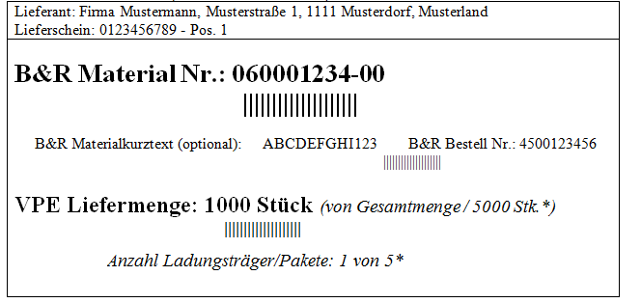

**1**

**2**

**3**

**5**

**6**

**7**

**4**

## Material ID label

The material ID label must contain the following information:

1. B&R material number in text and as bar code
2. Package quantity
3. B&R purchase order number
4. Manufacturer product name
5. Date code (optional, as per agreement)



**4**

**2**

**3**

**1**

# Abbreviations

The following sections will contain references to these abbreviations and colors:

* VPE: Packaging unit
* P: Packages
* LS: Delivery note
* MKE: Material ID label
* PE: Package label

# Packaging load carriers

Preferably, a load carrier should contain a single type of item.

Load carriers must not exceed a height of 1.9 meters or a weight of 900 kg.

Load securing measures must comply with current traffic regulations and current regulations for the prevention of industrial accidents.

## Single-type load carriers

A load carrier is considered single-type when it contains just one type of product.

### Single-type load carrier with packaging units

Single-type load carriers with packaging units must be packed as follows:

* Each packaging unit must be identified with a material ID label.
* Each single-type load carriers must be identified with a package label. This label must indicate how many load carriers are being used for the delivery item   
  (e.g. load carrier 2 of 5).
* A delivery note must be provided for each delivery unit.

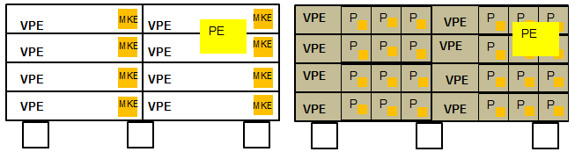

LS

### Single-type load carrier with outer packaging (packages)

Single-type load carriers with outer packaging (packages) which contain packaging units must be packed as follows:

* Each packaging unit must be identified with a material ID label.
* Each single-type packages must be identified with a material ID label.
* Each single-type load carriers must be identified with a package label. This label must indicate how many load carriers are being used for the delivery item   
  (e.g. load carrier 2 of 5).
* A delivery note must be provided for each delivery unit.

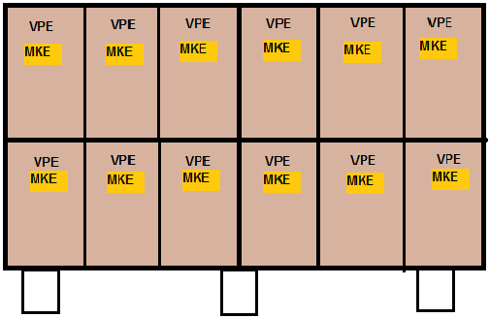

**P**

**P**

**P**

**P**

PE

LS

### Weight distribution

The packaging units must be distributed evenly on the load carrier. A one-sided distribution of weight is not permitted.

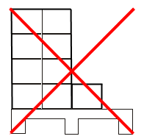

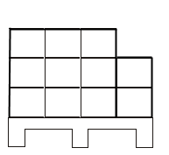

### Positioning the packaging units on the load carrier

The packaging units must be positioned in such a way that there is a margin of at least 4 cm on each of the four edges.

Exception: if the dimensions of one individual packaging unit exceed this specification.

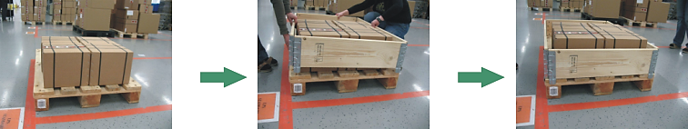

## Load carrier with a mix of products

A load carrier with a mix of different products is one that has been packaged with different delivery items (products).

### Load carrier with a mix of products in packaging units

Load carriers with a mix of products in packaging units must be packaged as follows:

* Each packaging unit must be identified with a material ID label.
* A delivery note must be provided for each packaging unit.

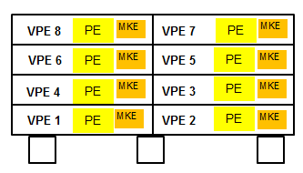

LS

LS

LS

LS

LS

LS

LS

LS

### Load carrier with a mix of products in single-type packages

Load carriers with a mix of products in single-type packages that contain packaging units must be packaged as follows:

* Each packaging unit must be identified with a material ID label.
* All packages must be identified with a package label. This label must indicate how many packages are being used for the delivery item   
  (e.g. package 1 of 2).
* A delivery note must be provided for each package.

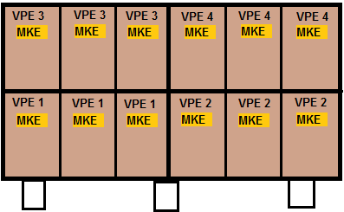

**P1**

PE

LS

PE

PE

PE

LS

LS

LS

**P2**

**P3**

**P4**

### Load carrier with non-single-type packages

Load carriers with packages that contain a mix of different products must be packaged as follows.

* Each packaging unit must be identified with a material ID label.

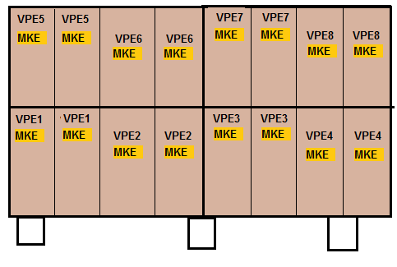

LS

LS

LS

LS

**P3**

**P1**

**P4**

**P2**

* A delivery note must be provided for each package.

**Dividing up products into multiple packages is not permitted.**

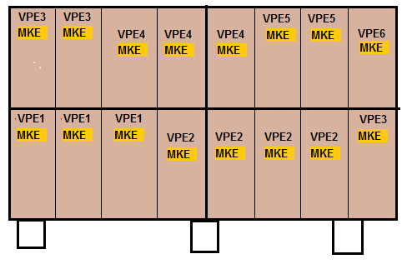

LS

LS

LS

LS

**P3**

**P1**

**P2**

**P4**

### Positioning packaging units or packages

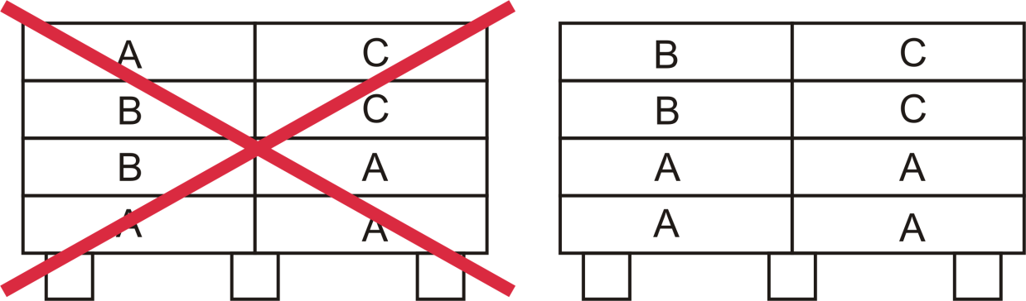On mixed pallets, the packaging units or packages must be systematically arranged so that identical materials are positioned next to or on top of each other.

# Packaging package deliveries

## Single-type packages

Single-type packages must be packed as follows:

* Each packaging unit must be identified with a material ID label.
* Each single-type delivery units (packages) must be identified with a package label.
* 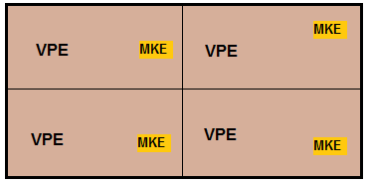A delivery note must be provided for each package.

LS

PE

### Mixed packages

Packages that contain multiple delivery items (products) must be packaged as follows:

* Each packaging unit must be identified with a material ID label.
* A delivery note must be provided for each delivery item (different materials).

VPE1

VPE 1

VPE 2

VPE 2

MKE

MKE

MKE

MKE

LSS

LSS

# Inspection documents

Inspection documents must be provided with the goods if part of the delivery contracts.

# Maximum delivery weight

The following maximum weight values are not allowed to be exceeded:

* Maximum 20 kg for packages / packaging units
* Maximum 900 kg for single-type load carriers (EUR-pallets)

# Using packaging materials

Packaging material must adhere to all applicable environmental regulations and provisions. All disposable packages must be visibly marked with standardized images and codes (in accordance with DIN 6120) or symbols that are recognized by waste management authorities.

Labeling, tape, fastening strips and material tags must not impair the recycling process.

# Labels on circuit packaging

Warehouse equipment provided by B&R (circuit packaging) must be labeled using labels that are free of residue from the warehouse equipment and that can be easily removed.

# Exchanging palettes

EUR-pallets must be clean and dry and comply with the exchange criteria published by EPAL. Palettes that do not comply with these guidelines will not be accepted and therefore not exchanged (www.epal-pallets.org).

# Protection against damage

The supplier is responsible for packaging items that require additional protection.   
For example:

* Electronic components must be packaged in ESD-safe containers, warehouses, belts, etc. in accordance with EN 61340-5-1.
* Corrosive materials must be enclosed in packaging that prevents corrosion.
* Materials with coated and/or sensitive surfaces must be packaged in a way that protects these surfaces (e.g. intermediate padding in packaging units).
* Printed circuit boards (electronic components) must be packaged in ESD-protective packaging or containers in accordance with EN 61340-5-1.

# Consequences resulting from failure to follow delivery guidelines

The supplier will be billed for any expenses resulting from failure to follow delivery guidelines. B&R retains the right to reject any shipments that do not comply with the requirements described in sections 3 to 14 (acceptance rejection). The cost for the return shipment will be paid for by the supplier.

1. All bar codes should be in Code 128 or Code 39 form.